SECTION MEETING RECAP: 9/24/14
Instructor: Jess Karanian

Homework: “Assignment 4: Exam Questions”
Due: Wednesday 9/24 in Discussion. Must upload to Canvas before class.

Key Concepts
(1) Sampling & Estimation: Demonstration
Sampling with replacement – requires that you replace each score back into the pool of scores and then resample; this is the basis for statistical theory

Sampling without replacement –when you sample and then do not replace, but instead continue sampling from the population; commonly used in practice by researchers

What happens when you have N=2 vs N=4?
-the variability decreases with larger sample
-larger sample reduces/quiets the influence of outliers/extreme scores

Central Limits Theorem: the tendency towards normality in the distribution of sample means is stronger with larger sample sizes; an infinite number of cases will produce a normal bell-shaped curve
-it is ideal for your sample to display a normal distribution; if not, there may be a sampling error/bias

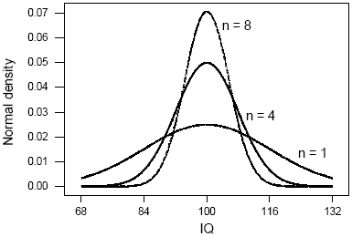

(2) Estimation of the Population Mean and Variance from Sample Data
-A researcher only selects one sample and calculates the mean, variance, and standard deviation for that one sample
-Ideally, the sample chosen is representative of the population
-Bigger samples tend to provide a better estimate of the mean and variance of the population estimate

Sample Mean: $\frac{∑X}{N}$
-The mean of all samples will equal the population mean
-however, researchers VERY rarely can include an entire population in their study
-therefore, it is often necessary to estimate it

Biased Sample Variance: S² =$\frac{ ∑ (X - MEAN)2}{(N)}$
-this formula yields a systematically biased estimate of the population variance
-the estimate will be too small

Unbiased Sample Variance: S² =$\frac{ ∑ (X - MEAN)2}{(N-1)}$
-this formula yields a better estimate of the population variance

Other notes: the mean is more stable than the median [i.e., it varies less from sample to sample]

