SECTION MEETING RECAP: 9/17/14
Instructor: Jess Karanian

Homework: Posted on Canvas under Assignments within our section meeting:
“Assignment 2: Stem and Leaf” and “Assignment 3: Nominal Data
Due: Friday, 9/19 at 11:59pm.

Key Concepts
Part 1. Summation Notation
Distribution of Scores: 2, 3, 3, 4
∑X = (2) + (3) + (3) + (4) = 12
∑X² = (2²) + (3²) + (3²) + (4²) = 38
(∑X)² = (12)² = 144
MEAN: $\frac{∑X}{N}$ = $\frac{12}{4}$ = 3
SUM OF SQUARES: ∑ (X - MEAN)² = [(2-3)² + (3-3) ² + (3-3) ² + (4-3) ²] = [(-1) ² + (0) ² + (0) ² + (1) ²] = 2
(∑ (X - MEAN))² = [(2-3)+ (3-3) + (3-3) + (4-3)] = [-1 + 0 + 0 + 1] ² = [0]² = 0

Part 2. Stem & Leaf Plots
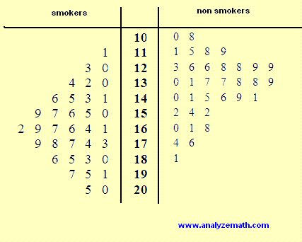
-Pick a good stem. Look at the data, find the lowest and highest score, and decide the best way to present it.
-Each score must take up the same amount of space/area to assure proper representation
-Observe the general shape of the distribution.
-Estimate the mean. Where do most of the scores lie?
-Are the distributions skewed? Look for asymmetry.
-What does the variability of scores look like? Look at how spread out or tightly clumped the scores are.

Part 3. Nominal Data
-Assure that categories are well defined for the respondents.
-A way to improve the scale: provide a fixed set of alternatives for respondents.
-How many categories are ideal? Offering many categories retains a lot of detail, but adds clutter.
-“Other” category is useful so that each hand every respondent has some answer to provide
-Always consider the population being measured. Adjust scales based on your sample.
-Ethical concern: Entire data set should not be published without permission to assure anonymity.
-A way to assure anonymity: save data file in parts to remove linkage of identifying information (ex. height)

Part 4. Mean vs. Median / Skew
Distribution of Scores: 100, 120, 100,000
Median = 120
Mean = 33,407
-The mean is heavily influenced by extreme values as it is sensitive to outliers 