SECTION MEETING RECAP: 9/10/14
Instructor: Jess Karanian
Office Hours: Friday 10am-12pm in McGuinn 316
Email: jessica.karanian@bc.edu

Homework: Posted on Canvas under Assignments within our section meeting, “Sampling in Brownell et al. 1983”
Due: Friday, 9/12 at 11:59pm.

Key Concepts

Population: this is the group of people that you are interested in studying and plan to draw conclusions about

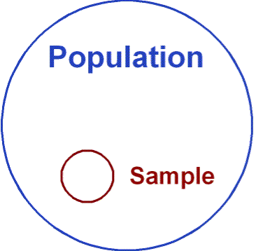
Sample: the group that you test from your broader population
Example 1)
-Population = All young adults in the USA
-Sample = 40 BC Psychology students looking for course credit

Example 2)
-Population = People with PTSD
-Sample = 100 hospital patients with a PTSD clinical diagnosis

Convenience sampling – as the name suggests, this is the idea of drawing participants for a study from wherever is easiest. It is dangerous because it limits your sample and often introduces selection biases
Example) Sampling only BC psychology students may not be representative of the population
-for example, BC students may have different values, upbringings, IQs, etc than students at a different university, so these factors may result in biased results

Representative Sample: this is the idea that your sample truly reflects the population you are testing
Example) If you are doing a study on average height of BC students, you wouldn’t just survey the BC basketball and volleyball teams as neither is representative of the general BC student population
-a better way: sitting outside of the dining hall and measuring every 10th person to walk by you (this is random sampling, and it helps assure that the sample is representative of the population)

Random assignment: this is when the experimenter assigns participants to the “experimental group” or the control group
Example) In Brownell et al. (1983), there was no random assignment as patients arrived to the study as either “right hemisphere damaged” (experimental group) or “neurologically intact” (control)
-a better way: assign all participants randomly to a group, and then produce a temporary lesion via TMS; or use animals and create a lesion after group assignment

Selection Biases: certain factors may bias your sample, making it not representative of the broader population
Example) In Brownell et al. (1983), the sample consisted of only male in-patient veterans – can results truly be reflective of the broader population?
-a better way: recruit stroke patients from all over the US, include females, include civilians, control for age of the participant, control for psychological illness / trauma, control for intelligence and education, etc.

