Z-Score Worksheet
10/8/14
Name: __________________________________________________

(1) Write down the z-score formula.

(2) Calculate your own z-score relative to females in our class based on the following info. Show your work.
n = 75
µ = 64
σ = 5

(3) Calculate your own z-score relative to males in our class based on the following info. Show your work.
n = 50
µ = 71
σ = 4

(4) Calculate your own z-score relative to the whole class based on the following info. Show your work.
n = 125
µ = 67
σ = 6

(5) Did your z-score change? If so, why?

(6) Using the below z-distributions, indicate where your z-score approximately falls on each distribution.

(a) Females

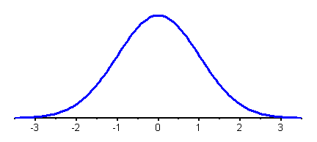

(b) Males

(c) Whole class

(7) Re-write your z-score on the line for each category. Turn to the z-score table at the back of this packet, find your z-score for each category (i.e., females, males, and whole class) under the column “z”. Then, record the corresponding values for “larger proportion” and “smaller proportion” for each z-score on the lines below. NOTE: This table is taken from Howell, pg 598-601.

(a) Female z-score = ________

Larger Proportion = ________
Smaller Proportion = ________

(b) Male z-score = ________

Larger Proportion = ________
Smaller Proportion = ________

(c) Whole class z-score = ________

Larger Proportion = ________
Smaller Proportion = ________

(8) Complete the following statements.
-If z-score is positive, multiple the “larger proportion” by 100 to get percentile.
-If z-score is negative, multiply the “smaller proportion” by 100 to get percentile.
-An easier way: look back to your z-score graph on Pg. 2 to help you choose the correct proportion.

(a) I am taller than ________ % of females in our class.

(a) I am taller than ________ % of males in our class.

(a) I am taller than ________ % of our whole class.

